Project design phase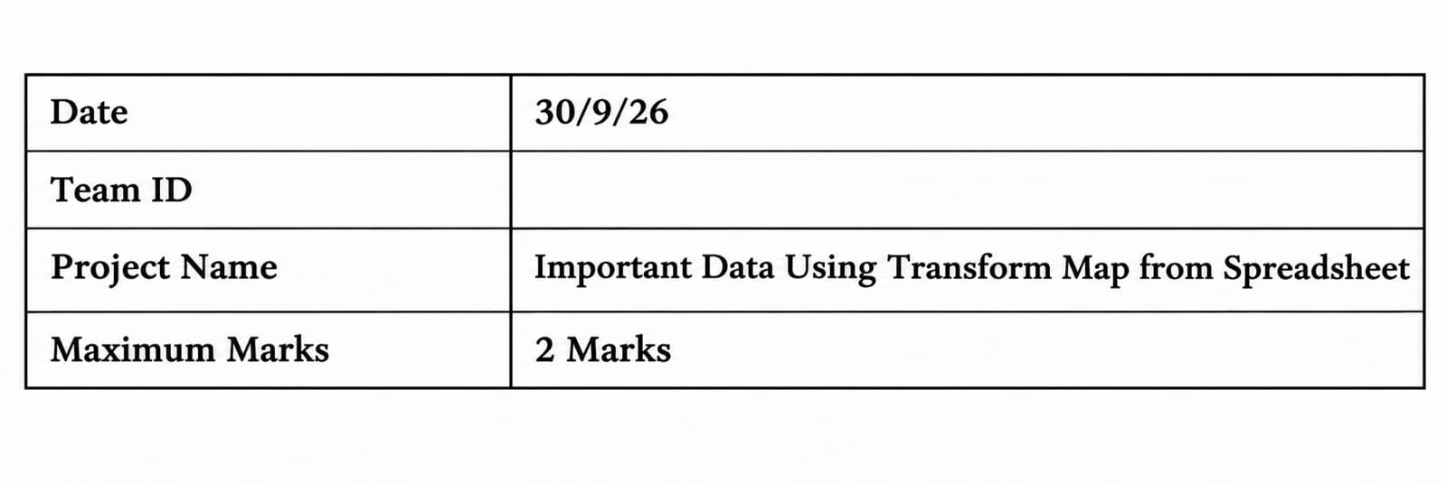

Problem solution:

project, “Import Data Using Transform Map Using Spreadsheet,” focuses on importing employee information into ServiceNow.

The employee spreadsheet contains details such as Employee ID, Name, Email, Department, and Location. Instead of manually entering each employee record, the spreadsheet is uploaded through an Import Set. The data is temporarily stored in the Import Set Table and then processed using a Transform Map.

The Transform Map connects the spreadsheet fields with the corresponding ServiceNow table fields. Employee ID can be used to identify an existing employee. If the Employee ID already exists, the system updates the existing record. If it does not exist, the system creates a new employee record

Purpose:
The purpose of this Problem-Solution Fit Canvas is to clearly identify the problems faced when importing employee data into ServiceNow and show how the proposed Import Set and Transform Map solution addresses those problems.
It helps connect the customer needs, problems, existing solutions, user behaviour, root causes, proposed solution, and expected results in one simple framework.
For this project, the main purpose is to show how employee data can be imported from an Excel/CSV spreadsheet into ServiceNow with less manual work, better field mapping, and fewer data-entry errors.
Template:

